Functional and technical analysis

Payment methods

# Table of content

1 Table of content 2

2 Credit Card 5

2.1 General description 5

2.2 Contract data 6

2.2.1 Navigation 6

2.2.1.1 Request Origination 6

2.2.1.2 Destinations 6

2.2.2 Dependent processes 6

2.2.2.1 External services 6

2.2.2.2 Mailing system 6

2.2.2.3 Action tracing 7

2.2.2.4 Auditing 7

2.2.2.5 Logging 7

2.2.3 Fields and validation 9

2.2.4 Action events 12

2.2.4.1 Load 12

2.2.4.2 Page rendering 13

2.2.4.3 Operations 18

2.2.5 Security 27

2.2.5.1 Common 27

2.2.5.2 Save 27

2.2.5.3 Show “Confirm UID with automatic check” button 27

2.2.5.4 Show “Confirm UID is OK with NO check” button 28

2.2.5.5 Show “Set UID NOT OK” and “Just test UID” button 28

2.3 Backend info 29

2.4 3D-Secure activation 30

2.4.1 Navigation and/or Flow 30

2.4.2 Dependent processes 30

2.4.2.1 External services 30

2.4.2.2 Mailing system 30

2.4.2.3 Action tracing 30

2.4.2.4 Auditing 30

2.4.2.5 Logging 31

2.4.3 Fields and validation 31

2.4.4 Action events 31

2.4.4.1 Load 31

2.4.4.2 Page rendering 32

2.4.4.3 Operations 34

2.4.5 Security 37

2.4.5.1 Common 37

2.4.5.2 Save 37

2.5 Payment method specific options 38

2.5.1 Navigation and/or Flow 38

2.5.1.1 Request Origination 38

2.5.1.2 Destination 38

2.5.2 Dependent processes 38

2.5.2.1 External services 38

2.5.2.2 Mailing system 38

2.5.2.3 Action tracing 38

2.5.2.4 Auditing 38

2.5.2.5 Logging 38

2.5.3 Fields and validation 39

2.5.4 Action events 40

2.5.4.1 Load 40

2.5.4.2 Page rendering 40

2.5.4.3 Operations 42

2.5.5 Security 44

2.5.5.1 Common 44

2.5.5.2 Save 44

2.6 Acquirer options 45

2.6.1 Navigation and/or Flow 45

2.6.1.1 Request Origination 45

2.6.1.2 Destination 45

2.6.2 Dependent processes 45

2.6.2.1 External services 45

2.6.2.2 Mailing system 45

2.6.2.3 Action tracing 45

2.6.2.4 Auditing 45

2.6.2.5 Logging 45

2.6.3 Fields and validation 46

2.6.4 Action events 47

2.6.4.1 Load 47

2.6.4.2 Page rendering 48

2.6.4.3 Operations 48

2.6.5 Security 50

2.6.5.1 Common 50

2.6.5.2 Save 50

2.7 Payment method activation 51

2.7.1 Navigation and/or Flow 51

2.7.1.1 Request Origination 51

2.7.1.2 Destination 51

2.7.2 Dependent processes 51

2.7.2.1 External services 51

2.7.2.2 Mailing system 51

2.7.2.3 Action tracing 51

2.7.2.4 Auditing 51

2.7.2.5 Logging 51

2.7.3 Fields and validation 52

2.7.4 Action events 53

2.7.4.1 Load 53

2.7.4.2 Page rendering 53

2.7.4.3 Operations 54

Updates the merchant cards below detail 55

2.7.5 Security 56

2.7.5.1 Common 56

2.7.5.2 Save 57

# Credit Card

## General description

There are various payment methods/brands supported for credit card such as below

* Accor Business Account
* AIRPLUS
* Alsolia
* Aurora
* Aurore
* American Express
* Billy
* Bancontact/Mister Cash
* Club Med
* Cofinoga
* Cyrillus
* Dankort
* Diners Club
* DISCOVER
* FNAC
* Go Sport
* JCB
* Kangourou
* Laser
* Maestro
* Mandarine
* MasterCard
* MaestroUK
* OKShopping
* Printemps
* Privilège
* QUATREETOILES - 4 étoiles
* Surcouf
* UATP
* VISA

## Contract data

### Navigation

#### Request Origination

Payment method details can be requested from payment methods list page. Payment methods list will contain two tabs and both the tabs will have payment methods list. Contract data will be the default view from both the list.

#### Destinations

User can take below action

**Save:** On clicking of save, contract data will be updated and user will stay in the same view.

### Dependent processes

#### External services

There are various backend COM communication is needed and below are such methods

1. GetFacade(facadeobj, BESERVER)
2. facadeobj.GetMerAcqUIDList(session("pspid"), rs0_acquirers.Fields("ACQUIRERNC").value)
3. facadeobj.SaveMerAcqUIDList(session("pspid"), rs0_acquirers.Fields("ACQUIRERNC").value, rsUID , sError)
4. facadeobj.getemptyMerchantConfigRS
5. facadeobj.SaveMerchantConfigRS(session("PSPID"),rs_MerchCfg)
6. facadeobj.AddMerchantConfig(session("PSPID"),ACQUIRERNC,UID & "/" & TID,BRANDNC,companyname,ManualNeeded,merchantflags)
7. facadeobj.GetDefaultMerchantAppParamsRS(sBeAppToUse)
8. facadeobj.SaveMerchantAppParamsRS(rsBeApp, Session("PSPID"), sRealAcquirerNc, sBeAppToUse)

#### Mailing system

Below notification mail is sent while add/update credit card payment method

1. An email is sent to acquirer (if acquirer email exists) and merchant for affiliation request while adding payment method. This notification is sent only below condition is satisfied
   1. Acquirer is BCC
   2. Merchant’s ISP is not TST
   3. Merchant’s account is not TEST account
   4. It’s not a collecting contract used
2. An email is sent for manual configuration of payment method to cavaer admin if
   1. Payment method brand is BCMC
   2. Collecting contract is activated for merchant
   3. Current user is not ABSSYS

This notification mail is sent to admin of cavaer but if current environment is DEVELOPMENT then it is sent to “[mail_ogonetest@ogone.com](mailto:mail_ogonetest@ogone.com)”.

1. An email is sent for activation of BCMC payment method. If collecting contract is not activated then email is also sent to acquirer.
2. Notification email is sent when payment method configuration is updated for VISA, Eurocard and Master Card brand and should not be Purchasing card

First gets the UID and TID for other brand. For example if current brand is VISA then get UID, TID for Eurocard and if current brand is Eurocard/Master card then get detail for VISA brand. If details are found then send mail for FR acquirers otherwise send to non FR acquirers. This mail is sent only once.

For FR acquirers, mail is sent to EMAILUID field of ACQUIRERS table and for non FR acquirers; it should be sent to EMAILUIDISP field. If EMAILUIDISP is empty then sent to EMAILUID

1. Notification email is sent whether back end configuration is OK or KO after updating merchant data to back end database. This email is sent to [Support@ogone.com](mailto:Support@ogone.com).
2. Notification alert is sent to merchant when automatic UID is validate successfully and updated. Copy of the mail is also sent to the technical email address of the merchant.

#### Action tracing

If any merchant information is modified then it is traced and added in ACTIONTRACE table. Apart from merchant configuration change, other action trace information is also logged such as below

* When setting UID is OK without checking with acquirer.
* When setting UID not ok
* When validating UID and if check is unsuccessful
* When validating UID and check is successful
* When validating UID and check is successful and also status is changed

#### Auditing

An event is raised for auditing and notification is sent. Below are such events where auditing will be done

* When acquirer information is not found for selected merchant
* While getting the options to find whether payment method is chargeable each time it is added or not, if more than one record found then auditing event is raised.
* If no record found while finding the NEXTVALUE from NEXTVALUESMULT table to get new TID value, it raises the audit event.
* If any error occurred and backend configuration is not updated then raised an audit event

#### Logging

All the minor information is logged in file. Below are such events where information is logged for

* acquirer mode is test
* Selected acquirer
* Selected contract
* Any entity data not found
* Update completion bit
* Update UID field

### Fields and validation

|  |  |  |  |
| --- | --- | --- | --- |
| **Field name** | **Description** | **Validation rules** | **Error messages** |
| Contract | Two radio options are available for contract. This option is only visible if merchant account is TEST account. | Int |  |
| One option must be selected | Please select one option |
|  |  |
|  |  |
| Acquirer | Acquirer list | String |  |
| Required | Acquirer is required |
| UID | UID | String, Alphanumeric |  |
| Max length: 30 |  |
| TID | TID | String, Alphanumeric  ForBCMC, it’s Numeric and must be 8 characters long. It must start with 01 | TID is invalid. |
| Max length: 20 |  |
| AcquirerConfirmed | Acquired confirmed – two options for yes or not | Int |  |
|  |  | Required |  |
| Country | Country list | String |  |
| Send mail to banksys | Two options – only used when BCMC is selected | Disabled |  |
| Flags_CAP | Used when BCMC is selected | Disabled |  |
| Affiliation date | Only used when BCMC is used | Disabled |  |

**MCC (Merchant Category Code) validation**

If activation selected is 1 and MCC is mandatory and not configured then below error message displayed

*MCC code is mandatory before payment method activation is possible*

MCC value is based on the REQ_FIELDS field of the ACQUIRERS table. If the value is configured like MCC=xxx then it is required to be submitted and dynamically text area is generated.

**Validate UID**

To validate the UID, it is sent to acquirer for checking the correct UID. For this, backend call is done using CheckMerchantUID method which expects various parameters. Below are such parameters

* PPSID: Current merchant pspid
* Brand: BrandNC field value from cards table
* Currency: CURCATAL field of MERCHANTCARDS table based on current merchant pspid.
* If selected brand is VISA or EUROCARD then CURPAID field is used.
* ECI: ECI list from MERCHANT table
* btTRNFLAGS2:?
* Message: Depends on ECI values.

For example if ECI is 7 then message will be "7 => e-Commerce (7/9)"

If ECI is 1 then message will be "1 => MOTO (1/2)"

All other cases message will be “Default merchant ECI"

* UID: UID value
* Acquirer: Current selected acquirer
* App:?
* Error: Error from backend call
* TransactionId:?

Based on the above call, below result can be expected

* If result is 0 then UID check successful
* If result is 1 then UID refused
* If result is 2 then result not sure for acquirer
* If result is 3 then UID check not available
* If result is 4 then unexpected result

### Action events

#### Load

This view can be requested from payment method list. There are two tabs which are

1. Selected payment method
2. Choose new payment method

If request is coming from selected payment method then contract data will be opened in editable form because payment method is already added.

If request is coming from choose new payment method then contract data will be blank and new entry will be added.

Gets the merchant detail based on the current selected merchant. If merchant does not exists then redirects to the error page.

Gets ISP detail such as ACQUIRERS_ISP based on the merchant’s ISP field.

Gets the acquirer details based on dynamic conditions. All the acquirers’ details are sorted by company name.

Acquirers’ records are filtered by

* ACQUIRERS.SUPPORTEDCARD = <SlectedBrand>
* ACQUIRERS.LOCALCOUNTRIES
* ACQUIRERS.EXCLUSIVE_ISP
* ABONNEMENT.REJECTED_PM and ABONNEMENT.EXLUSIVE_PM

Gets the CARDS detail based on the BRAND, LOCALCOUNTRIES and matching the records with acquirers supportedcard field of card’s brand field.

If selected brand is “BILLY” then gets the ACQUIRER, UID, TID from MERCHANTCARDS based on the below condition

* MERCHANTCARDS.PSPID = <CurrentPSPID>
* MERCHANTCARDS.BRAND = <EUROCARD>
* MERCHANTCARDS.ACTIVATION=<1>
* ACQUIRER = <All the acquirer from ACQUIRERS table where supportedcard is billy>

**Allowed Payment Method?**

Check is made on whether payment method is allowed or not for merchant’s subscription is done. REJECTED_PM and EXCLUSIVE_PM fields are selected from current subscription.

If EXCLUSIVE_PM value is not empty

If selected payment method brand is part of the EXCLUSIVE_PM list then selected brand is allowed to add/edit otherwise error page is shown

If REJECTED_PM is not empty

If selected payment method brand is part of the REJECTED_PM list then payment method is not allowed to add/edit and error page is shown

**Edit Form:**

Gets the details from merchant cards based on the current merchant, acquirer if any and brand. It’s also checking the acquirer field of the merchant card is acquirer field of acquirers table. If no records found then again selects the records without matching with acquirer table.

Gets the acquirer detail as above query but gets the record with ACQUIRERS.ACQUIRER is not ACQUIRER value if it’s not a TEST environment.

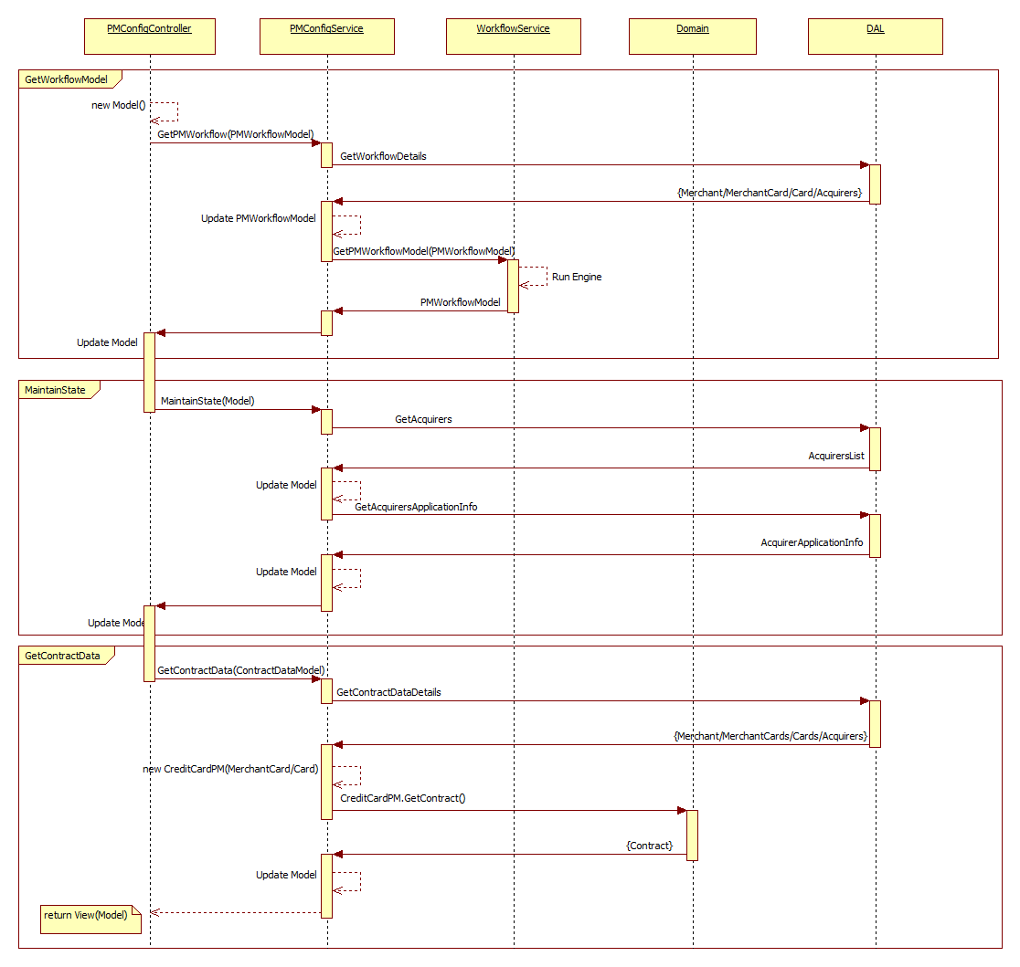

**Figure: Load Contract Data Sequence Diagram**

#### Page rendering

Below are the various sections displayed on contract data. Sections are visible based on the brand and various configurations.

1. Do you use your collecting contract?

This section is rendered if merchant has activated collecting contract and brand support collecting contract. To activate collecting contract, MERCHANT.OPTIONS6 bit position should be set to 4096. BCMC is the only brand that supports collecting contract.

This panel will display information on collecting contract and two action button which are “Yes” and “No”.

1. Do you have a contract?

This section is used for specifying whether merchant has contract with acquirer or not. View differs for Test merchant account and production merchant account

**For TEST merchant account:**

Two radio options are displayed as below

* I have not yet signed a contract for distance selling with an acquiring bank*, but I want to activate this payment method now in test with a test affiliation number.  
  (* An acquirer is a bank or financial institution that allows you to accept online payments)  
    
  However, in order to be able to accept this payment method when you transfer your test account to production, you need to sign a specific affiliation contract for distance selling with an acquiring bank.
* I have already signed a contract for distance selling with an acquiring partner.  
  NOTE: A contract for direct selling (real physical terminal in a store) does not allow you to accept online payments. Please make sure that you have a specific contract for distance selling. Please contact your acquiring bank for more information.

User must select at least one option from above options.

See below image

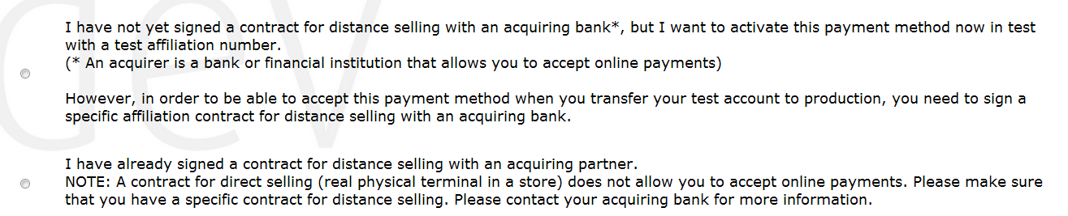

**For PROD merchant account:**

Below information on contract is displayed

* I have already signed a contract for distance selling with an acquiring partner.  
  NOTE: A contract for direct selling (real physical terminal in a store) does not allow you to accept online payments. Please make sure that you have a specific contract for distance selling. Please contact your acquiring bank for more information.

See below image



**Billy brand**

Billy brand is based on the configuration of master card payment brand configuration. It is only configured if master card is already configured. If selected brand is billy and master card brand is configured then below message displayed and no other configuration required

* Thank you for activating Billy. As Billy is a payment method supported by MasterCard, no additional configuration is needed as we copy your current MasterCard configuration in order to activate Billy in your account.

If master card is not configured then below error message displayed

* In order to activate Billy, you need to have an active connection with a MasterCard acquirer that supports this payment method. Please configure MasterCard and try again.

1. Select acquirer

This section renders two dropdown lists.

**Country**: This list is only visible if FACQ option is activated. List contains the two items, Merchant’s country and Other Country.

**Acquirer**: Lists all the available acquirer for selected country. See below image



1. Acquirer/Payment method specific data

This section displays the acquirer and payment method specific information.

If MERCHANDCARDS.AFFILDATE is not empty and if below condition is not satisfied

* Current user is ABSSYS OR (ISPCONFIG3 bit position is set to 256 and Current user’s minimum rights should be satisfied (ISP and ABSSYS should have >= 75 and rest should have 1000)) then below fields displayed.
* UID: if ISP’s subsidiary is not france and merchant’s FACCOUNTRY is not FR then “Affiliation number (UID/Merch ID/VP number)” caption displayed for UID otherwise “Affiliation number (VAD)” is displayed for UID.

If above condition is not satisfied then

* If MERCHANTCARDS.AFFILDATE is not empty then below information displayed

ATTENTION. ONLY OGONE USERS CAN CHANGE UID/TID/ACQUIRERS AFTER ACTIVATION. PLEASE PAY ATTENTION TO BACKEND CONFIGURATION CHANGES!!!!! AND TO MAINTENANCE OPERATIONS ON OUTSTANDING TRANSACTIONS!!!!!

* If selected brand is BCMC and MERCHANTCARDS.ACQCONFIRM is 0 and not test environment then link for BCMC contract info is displayed.
* UID: if ISP’s subsidiary is not france and merchant’s FACCOUNTRY is not FR then “Affiliation number (UID/Merch ID/VP number)” caption displayed for UID otherwise “Affiliation number (VAD)” is displayed for UID.
* TID: TID is displayed if below condition is not satisfied

Current user is ABSSYS OR (ISPCONFIG3 bit position is not set to 256 and current user should have enough access rights (ISP/ABSSYS should have minimum 75 and rest should have minimum 1000)).

See below image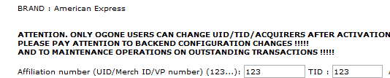

For BCMC brand:

Below are the additional fields that can be visible for BCMC brand

If current user is ABSSYS then

* Affiliation date or config mail sent to Banksys: This is the date field and always read only. Date is only updated when payment method is activated.
* FLAGS_CAP: Default value is 24 and always read only.
* TID

If current user is not ABSSYS then

* TID: If FLAG3 value is 131072 then field is not visible.

1. Multiple currency
2. Acquirer contract information/request

This section shows the information about acquirer contract request. It shows the information about acquirer contract and table which contains the below column

* Acquirer
* Time to get affiliated
* Means to get affiliated

See below image

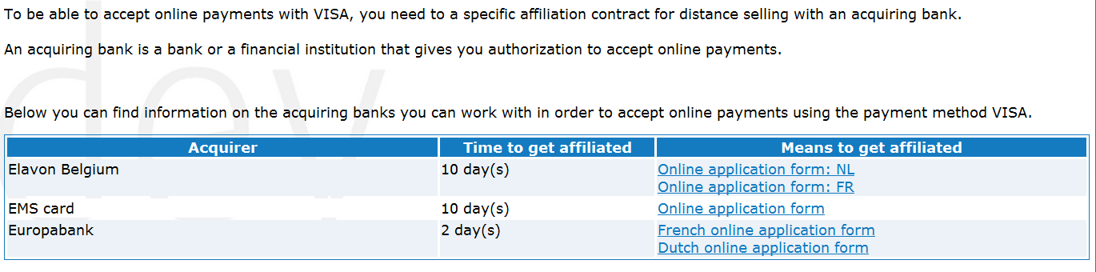

1. UID Check

There are various options available for UID check such as below

* Confirm UID is OK with automatic check
* Confirm UID is OK with NO check
* SET UID NOT OK
* Just test UID

These all options are visible based on security rights. Please refer the security section.

Also, information on UID is displayed as below

*The UID is given by the acquirer and is mentioned on the contract that you have signed with him. It is a numeric ID, generally between 4 and 13 digits.*

*When you have entered and confirmed your UID, we will give you a TID. This TID will be sent together with your UID for confirmation to your acquirer, who will activate your UID in his clearing system. You will then be able to accept payments. The whole activation process can last from a couple hours to a couple of days, depending on the acquirer.*

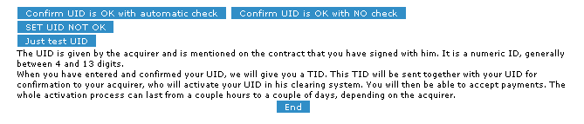

1. Acquirer confirm

This section shows whether the contract is confirmed by acquirer.



1. Mailing

This section is only visible if selected brand is BCMC and current is ABSSYS. There are two form fields for mailing as below

* Send mail to banksys (Yes/No): It is radio option and always read only.



#### Operations

##### Add payment method

Gets the merchant cards detail based on the current merchant’s PSPID and selected brand. If payment method already exists then update the record otherwise insert new payment method for merchant.

If the current mode is test mode i.e current merchant account is test and no contract received then

Gets the ACQUIRERS.ACQUIRER field based on below condition sorted by company name field

DEFLAGS2 = DEFLAGS2 & 16384

SUPPORTEDCARD = <CurrentBrand>

LOCALCOUNTRIES = <Based on the whether FACQ is activated or not>

EXCLUSIVE_ISP = <Dynamic Condition based on merchant’s ISP and ACQUIRER ISP)

If record found then take the first acquirer and if record not found then again query with below condition

SUPPORTEDCARD = <CurrentBrand>

LOCALCOUNTRIES = <Based on the whether FACQ is activated or not>

EXCLUSIVE_ISP = <Dynamic Condition based on merchant’s ISP and ACQUIRER ISP)

If ACQUIRER is selected from dropdown then ACQUIRER = <SelectedAcquirer>

If record found with above query then use the first acquirer from record set other wise use empty.

If current mode is not test and ACQUIRER is current selected acquirer from drpdown list

If collecting contract is used then ACQUIRER should be BANKSYS

If none of the above case exists then use empty string as acquirer.

Any entity can be updated if acquirer we found above is not empty otherwise nothing happens.

Gets the acquirer and cards detail from acquirer and cards table based on below condition

* ACQUIRERS.SUPPORTEDCARD = <SelectedBrand>
* ACQUIRERS.ACQUIRER = <SelectedAcquirer>
* LOCALCOUNTRIES = <Based on the whether FACQ is activated or not>

**Merchant Cards**

Below fields are updated when payment method is added

BRAND: Current selected brand

PSPID: current merchant PSPID

ACQUIRER: Acquirer from recordset

PAYMENTMETHODS: Payment method from recordset

FLAGS: DEFLAGS from recordset

FLAGS2: if Test mode then DEFLAGS2 & 16384 else DEFLAGS2 & ~16384

FLAGS3: DEFALGS3 from recordset

FLAGS_CAP: Default value 0 but 24 for BCMC and Maestro brand

CRITRIA_SCORING_WEIGHTS: '/18,R/22,R/23,R'

UID: if submitted value is not empty then use that value. If TEST mode and submitted value is empty then use 123.

TID: if submitted value is not empty then use that value. If TEST mode and submitted value is empty then use 123.

AffilDate: Sets the current date if TEST mode.

ACTIVATION: If current user is ABSSYS and merchant’s status is not subscribed and abssys user does not have 400 profile then activation set to 0 (No) else 1 (Yes).

If current brand is “Master Card” then it adds another record with brand EuroCard and payment method as creditcard

**Merchant**

Now gets the COMPLETION, STATUS and BRANDDETECTFLAGS from merchant table.

If merchant status is subscribed or inactive then update the merchant detail as below

Set COMPLETION = COMPLETION | 8

If merchant account is TEST and Activation is set to 1 and current brand is any of the SWITCH, BCMC, MAESTRO, QUATREETOILES, BILLY, CLUB MED, and DANKORT then update the BRANDDETECTFLAGS field as below

Set BRANDDETECTFLAGS = BRANDDETECTFLAGS | <BitValueBasedOnCurrentBrand>

Below are the bit values for specific brand

* SWITCH 🡪 2
* BCMC 🡪 4
* MAESTRO 🡪 8
* QUATREETOILES 🡪 16
* BILLY 🡪 32
* CLUB MED 🡪 128
* DANKORT 🡪 256
* LASER 🡪 512

**Collecting Contract:**

If merchant has activated collecting contract and payment method supports the collecting contract then few details are driven from database which merchant does not need to fill and such details are

* Acquirer: BANKSSYS
* FLAGS should be updated to set 131072
* PaymentMethod: Creditcard
* TID: 01014119

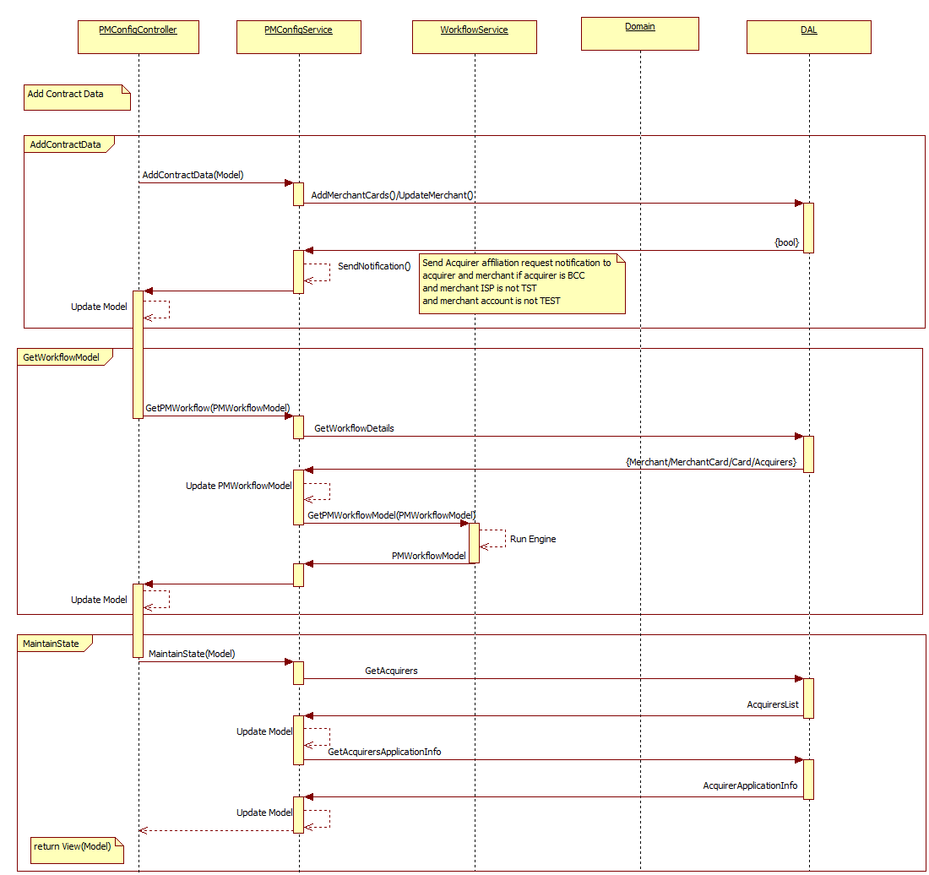

**Figure: Add Contract Data Sequence Diagram**

##### Update payment method

Gets the merchant cards detail based on the brand and pspid and updates the various fields.

First user rights are checked if user is able to activate the payment method or not. For that if ABSSYS user does not have 400 minimum profile and rest all user does not have 5 minimum profile then

If selected Activation field from form is different than stored in database OR merchant status is not subscribed or current user is not ABSSYS then report error and redirect to error page

Update UID, LASTACTIONDATE, FLAGS, FLAGS2, TID, ACQUIRER field. Also update the merchant. Please refer the Add payment method section.

**For BCMC Brand:**

Updates the FLAGS_CAP to 24

If TID is empty then finds the TID from merchant cards based on the below condition

* MERCHANTCARDS.BRAND = CARDS.BRAND
* PSPID = <CurrentPSPID>
* CARDS.PAYMENTMETHOD = <CurrentPaymentMethod>
* MERCHANTCARDS.TID LIKE ‘752%’ OR ‘755%’ OR ‘40F%’

If record found then assigns the found value to TID and update TID value.

If no record found from above query then gets the TID from NEXTVALUESMULT table and updated the TID value.

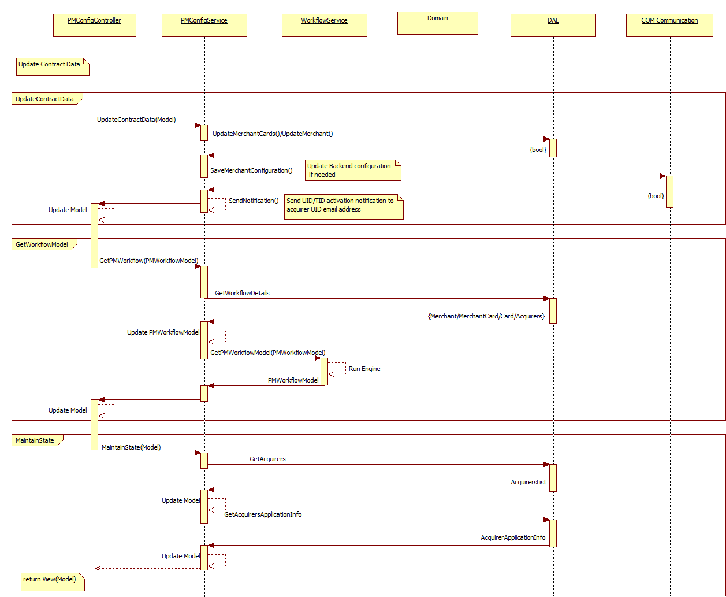

**Figure: Update Contract Data Sequence Diagram**

##### Update Backend Configuration

Gets the BRANDNC from CARDS based on the current selected brand.

Gets the ACQUIRERNC from ACQUIRERS based on the ACQUIRER = <CurrentAcquirer> and SUPPORTEDCARD = <CurrentSelectedBrand>.

Gets the back end merchant configuration and updates the merchant information in back end database.

Send notification mail whether back end configuration is OK or KO.

##### Confirm UID with automatic check

First validate the MCC, if MCC is mandatory and MCC value is empty then below error message displayed

*Please configure the MCC Code before using the UID check functionality*

*Refer MCC validation section in Forms and Validation*

UID is validated against the provided UID value. *Refer UID validation in Forms and Validation section*

If UID is validated correctly then updates the merchant card table and set the ACQCONFIRM to 2 based on the current selected brand, selected acquirer and merchant pspid. Displays the response and sends the warning mail.

If UID is not validated correctly then does not update ACQCONFIRM and information message displayed.

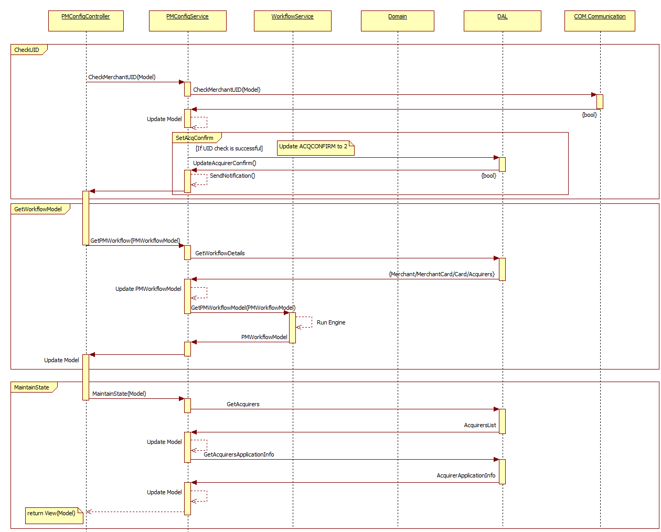

**Figure: Automatic UID Check Sequence Diagram**

##### Confirm UID OK with no check

First validate the MCC, if MCC is mandatory and MCC value is empty then below error message displayed

*Please configure the MCC Code before using the UID check functionality*

*Refer MCC validation section in Forms and Validation*

UID is not validated against acquirer and updates the merchant card table and set the ACQCONFIRM to 2 based on the current selected brand, selected acquirer and merchant pspid. Displays the response and sends the warning mail.

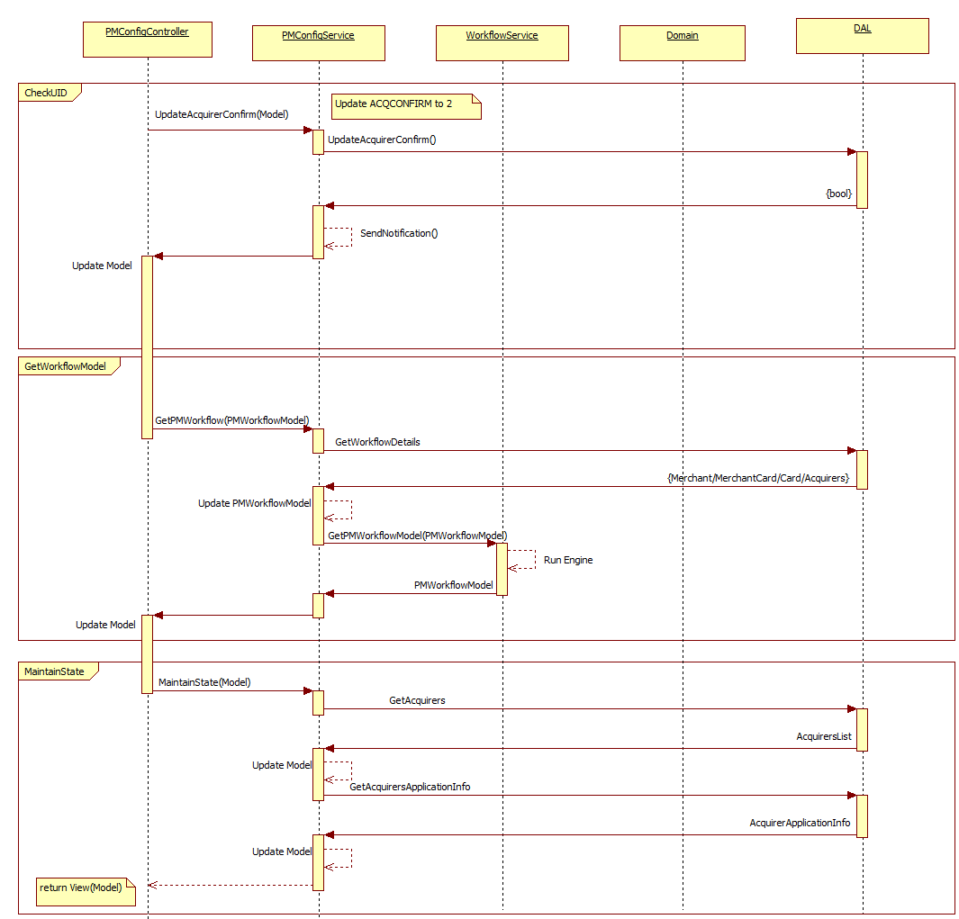

**Figure: Set UID OK with No Check Sequence Diagram**

##### Set UID Not OK

First validate the MCC, if MCC is mandatory and MCC value is empty then below error message displayed

*Please configure the MCC Code before using the UID check functionality*

*Refer MCC validation section in Forms and Validation*

Updates the MERCHANTCARDS.ACQCONFIRM to 0 based on the PSPID = <CurrentPSPID>, BRAND = <CurrentBrand> and ACQUIRER = <CurrentAcquirer>.

*Displays the message “Set UID to not checked for this brand”*

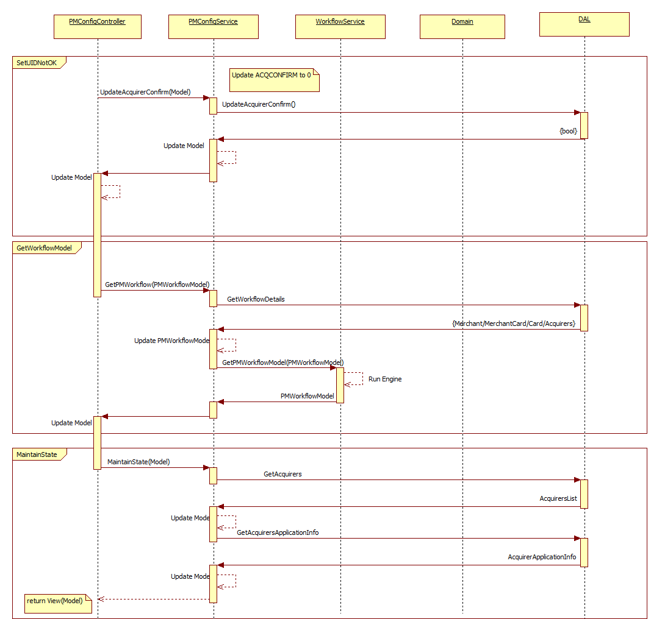

**Figure: Set UID NOT OK Sequence Diagram**

##### Just test UID

First validate the MCC, if MCC is mandatory and MCC value is empty then below error message displayed

*Please configure the MCC Code before using the UID check functionality*

*Refer MCC validation section in Forms and Validation*

This action is just used to test the UID value. UID is validated against the provided UID value. *Refer UID validation in Forms and Validation section*

Once it is validated, based on the result of the UID check result is displayed on the page.

If UID check is successful then below message displayed

*Check successful But UID status NOT changed.*

If UID check is unsuccessful then below message displayed

*Check unsuccessful But UID status NOT changed.*

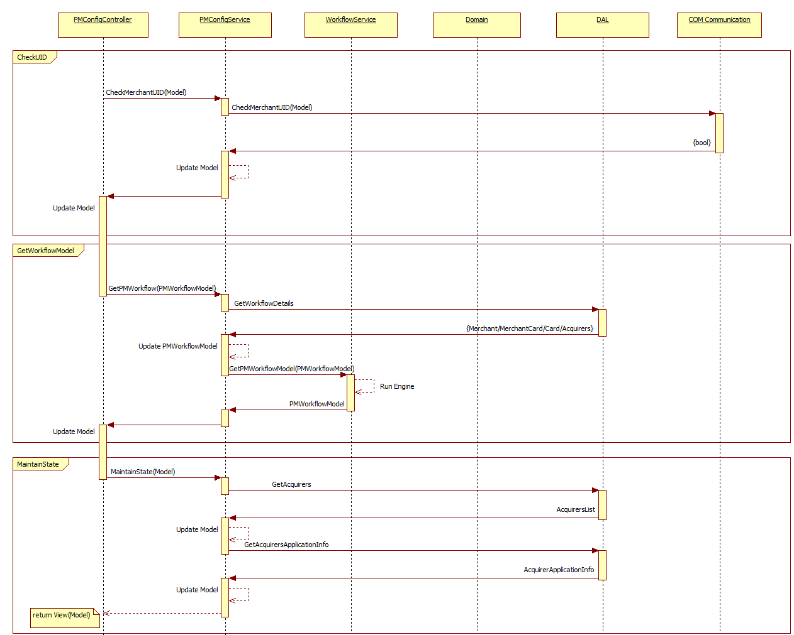

**Figure: Check UID Sequence Diagram**

### Security

#### Common

|  |  |  |  |  |  |  |
| --- | --- | --- | --- | --- | --- | --- |
|  | **Customer** | **Merchant** | **ISP** | **Acquirer** | **MerchantGroup** | **Ogone** |
| **Profile** | NA | 5 | 5 | NA | 5 | 5 |
| **User authenticated** | NA | Yes | Yes | NA | Yes | Yes |
| **CSRF validated** | NA | Yes | Yes | NA | Yes | Yes |
| **Merchant selected** | NA | Yes | Yes | NA | Yes | Yes |
| **User Action requested = View Account** | NA | Yes | Yes | NA | Yes | Yes |

#### Save

|  |  |  |  |  |  |  |
| --- | --- | --- | --- | --- | --- | --- |
|  | **Customer** | **Merchant** | **ISP** | **Acquirer** | **MerchantGroup** | **Ogone** |
| **User Action Requested = Change Account** | NA | Yes | Yes | NA | Yes | Yes |

#### Show “Confirm UID with automatic check” button

|  |  |  |  |  |  |  |
| --- | --- | --- | --- | --- | --- | --- |
|  | **Customer** | **Merchant** | **ISP** | **Acquirer** | **MerchantGroup** | **Ogone** |
| **Profile** | NA | 1000 | 75 | NA | 1000 | 75 |
| **MERCHANTCARDS.UID** | NA | Not empty | Not empty | NA | Not empty | Not empty |
| **MERCHANT.TEST** | NA | 0 | 0 | NA | 0 | 0 |

#### Show “Confirm UID is OK with NO check” button

|  |  |  |  |  |  |  |
| --- | --- | --- | --- | --- | --- | --- |
|  | **Customer** | **Merchant** | **ISP** | **Acquirer** | **MerchantGroup** | **Ogone** |
| **Profile** | NA | 1000 | 75 | NA | 75 | NA |
| **MERCHANTCARDS.UID** | NA | Not empty | Not empty | NA | Not empty | Not empty |
| **MERCHANT.TEST** | NA | 0 | 0 | NA | 0 | 0 |
| **Is ABSSYS user?** | NA | NA | NA | NA | NA | Yes |

#### Show “Set UID NOT OK” and “Just test UID” button

|  |  |  |  |  |  |  |
| --- | --- | --- | --- | --- | --- | --- |
|  | **Customer** | **Merchant** | **ISP** | **Acquirer** | **MerchantGroup** | **Ogone** |
| **Profile** | NA | 75 | 75 | NA | 75 | 75 |
| **MERCHANTCARDS.UID** | NA | Not empty | Not empty | NA | Not empty | Not empty |
| **MERCHANT.TEST** | NA | 0 | 0 | NA | 0 | 0 |

## Backend info

*Please refer the Payment methods – Common Features document*

## 3D-Secure activation

### Navigation and/or Flow

This is the third tab of the payment method configuration page. The screenshot will be updated later

Origin is the same as defined in contract data, while adding/updating new payment method and user successfully completed the “ContractData” tab details and S/he can access the 3D secure tab*.*

### Dependent processes

#### External services

Some external services will be use to validate the 3D secure parameters.

1. set rs_3DSReqresults = nc3.Process3DSReq(1, RDS_FACADE_IP, BESERVER, ThreeDSecureSocketTimeOutSeconds,rs_3DSReq)
2. set nc2= Server.CreateObject("NCMTSProxy.MTSProxy")
3. facadeobj.SaveMerchantAppParamsRS rs, PSPID_3d,ACQUIRERNC,ncapplication
4. Set rs = facadeobj.GetDefaultMerchantAppParamsRS("3DSECURE")
5. bProxyCreated = CreateObj("MTSPROXY", nc2)
6. set Fac3DS = nc2.Get3DSObj(RDS_FACADE_IP,RDS_FACADE_PORT, sServer)
7. iRes = Fac3DS.Check3DSReq(sPSPID, sBrand, sMessage, sStatus, sError)

#### Mailing system

An email notification is sent to merchant when 3D secure is activated. There is slightly different content for if merchant has activated full 3D secure or not.

A copy of the same notification is sent to acquirer email address as well. “EMAIL_3D” is the field for email address from acquirers table.

#### Action tracing

#### Auditing

An event is raised if there is no 3D merchant id and 3D password available for below acquirers.

* ACQUIRER
* BancSabadell
* Banco Popular
* BarclaysES
* Caixa
* BBVA
* Caixa Catalunya
* NBE
* Santander

#### Logging

### Fields and validation

|  |  |  |  |
| --- | --- | --- | --- |
| **Field name** | **Description** | **Validation rules** | **Error messages** |
| 3DSNotCompulsory |  | Bool |  |
| Optional |  |
| 3DSForbidden |  | Bool |  |
| Optional |  |
| Merchant Id |  | String, Alphanumeric, Optional |  |
| 3DPassword |  | String, Alphanumeric |  |
| Optional |  |
| 3DSAffiliateDate | Always read only | String |  |
| ActivateFull3D | Radio option. For BCMC, this will be a read only. | Int |  |
| If selected and value is greater than 0 then website field in merchant table must be configured | Impossible to configure 3DS, merchant's website address missing. |
| Order Form Sent to Banksys | Always read only. Only for BCMC |  |  |

### Action events

#### Load

To display the 3DS section for the payment, system need to verify few conditions and for that fetch few entities like

1. Gets the merchant detail based on the current selected merchant. If merchant does not exists then redirects to the error page.
2. Gets ISP detail such as ACQUIRERS_ISP based on the merchant’s ISP field.
3. Get the MerchantCards detail based on payment method, merchant and selected brand.

If the records are in editable mode, values of the fields are filled from merchant card table otherwise it display blank.

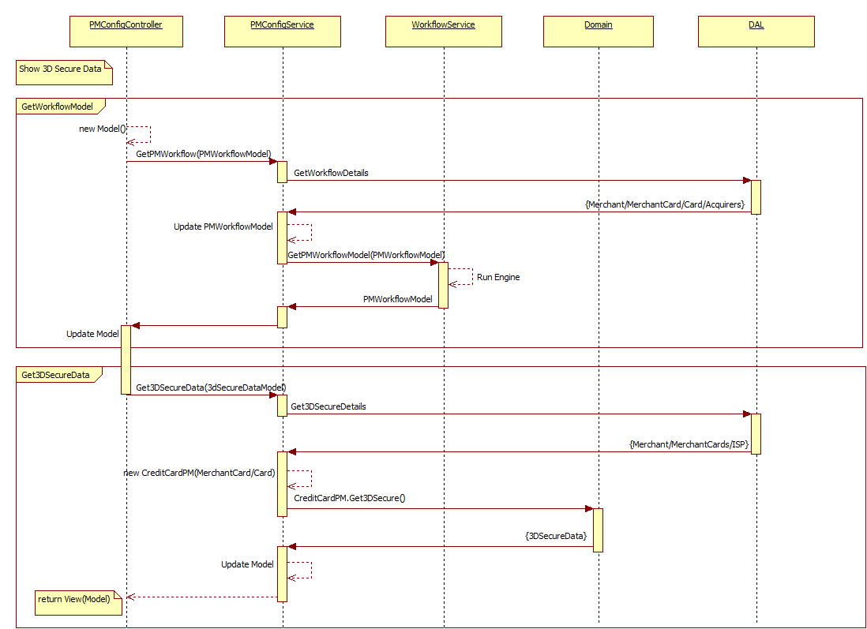

**Figure: Load 3D Secure Sequence Diagram**

#### Page rendering

3D secure activation will be displayed based on different parameters. Below are the conditions for that 3D secure section will be render on page

1. If logged in user is Abssys and
2. user should have permission of [1000,1000,75,1000,1000,75] OR ISPconfig3 &512 <>0
3. If the Acquirer select for the payment method is available in Acquirer table for selected brand
4. Or selected payment method brand is “BCMC” or “Maestro”
5. And in Acquirer table “Authent3D_Ena" filed is not empty

If all above conditions are satisfied, system renders 3D secure section. Again in this section few fields/labels are rendering based on different conditions. Below is the sequence of rendering.

1. Render common label “3-D Secure/SecureCode”
2. If CheckCap options (CheckCAP or checkCAP2 or CheckCAP0 or CheckCAP1) is enabled OR payment method brand “BCMC” or “Maestro”

Then render below items. See below screen for more reference

* 1. Option CAPx: Activated (this label and its value is fixed)
  2. Procedure stage: the value of this field is appear based on below condition
     1. If AND operation between “Completion_3D” value of merchant card table and 4 is 4 then value “Activation Completed”
     2. If AND operation between “Completion_3D” value of merchant card table and 2 is 2 then value “Back-end configured”
     3. If AND operation between “Completion_3D” value of merchant card table and 8 is 8 then value “Enrollment requested”
     4. If AND operation between “Completion_3D” value of merchant card table and 1 is 1 then value “Affiliation requested”
     5. Else, “Not requested” will be displayed in red color



There are some rules which override the 3DS compulsory rules. Meaning, if AND operation of “FLAG” field of merchantcards table with 1024 is 1024 then, 3DS compulsory flag will be set to true.

So,

1. If 3DS compulsory flag is true, then system render below things.

**3DS is compulsory for this acquirer**

System render two checkboxes for both above conditions along with message

1. Check box for “For this specific PSPID makes 3DS not compulsory”
2. Checkbox for “For this specific PSPID makes 3DS forbidden”
3. Else, if logged in user is Abssy then display message in red like

**3DS is not compulsory for this acquirer**

System render two checkboxes for both above conditions along with message

1. Check box for “For this specific PSPID makes 3DS compulsory”
2. Checkbox for “For this specific PSPID makes 3DS forbidden”



For DPR product merchant, system check couple more condition to render lable

1. If AND operation of Modenum field of merchant and 4 is 4 then
   1. If AND operation of “options5” and 128 is 128 then system render label

“DPR merchant and D3D flag active”

* 1. else

“DPR merchant and D3D flag NOT active”

After that, system render common fields for 3D secure for the payment method.

1. Merchant ID 3D – text field
2. 3D password - text field
3. 3DS affiliation date – label
4. Activate full 3D id (3D-Secure-SecureCOde, ...) – Radio button
5. Wallet (SPA-UCAF) only- Radio button
6. Deactive - radio button

After that if merchant has ChangeAccount right then display submit button

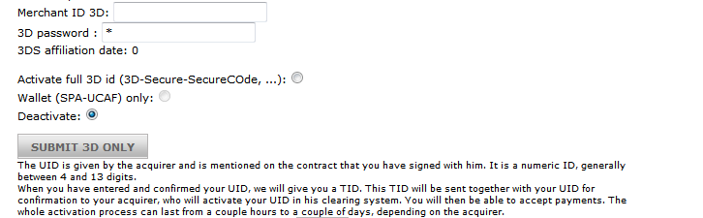

Remarks: if 3D secure not enabled for acquier then display message like

*3-D Secure/SecureCode not available for this acquirer.*

Also, if merchant payment method is not associated with any acquirer than display message like

*3-D Secure/SecureCode: The merchant is not affiliated yet with this acquirer.*

#### Operations

##### Update

**Merchant Cards**

First gets the FLAGS, FLAGS2, ACQUIRER, AUTHENT3D, ACTIVATION, MERCHID_3D, AFFILDATE_3D, COMPLETION_3D from merchant cards based on the selected brand and merchant id.

User rights are checked if user is able to activate the payment method or not. For that if ABSSYS user does not have 400 minimum profile and rest all user does not have 5 minimum profile then

If selected Activation field from form is different than stored in database OR merchant status is not subscribed or current user is not ABSSYS then report error and redirect to error page

**Validate Website:**

If ActivateFull3Ds form field is selected then website must be configured first. If it is not configured then below error message displayed.

*Impossible to configure 3DS, merchant's website address missing*

If Activate full 3D section is available/visible in the form then gets the ACQUIRER, SUPPORTEDCARD, MPITYPE based on the acquirer, supportedcard fields of merchant card.

If fetched MPIType is not empty then updates the 3D secure related below fields.

Updates the below fields of merchant cards table

FLAG: If “3DS not compulsory for specific PSPID” is activated (checked from form) then

Set FLAG = FLAG | 16384

FLAGS2: if “3DS forbidden for specific PSPID” is activated (checked) then

SET FLAGS2 = FLAGS2 | 1

COMPLETION_3D: This value is updated to COMPLETION_3D = COMPLETION_3D | 4 if activate full 3D is selected.

AUTHENT3D: Updated the selected value from form.

MERCHID_3D: Updated to entered form value if activate full 3D is selected.

AFFILDATE_3D: Updated to current system date

If MPIType is empty and Authent3D value is different than stored in DB then gets the card number and application name based on the brand. If card number is available then below action is executed

* Set the PSPID: If current PSPID is TESTCPC or TEST1 or TETS2 or merchant account is test then PSPID sent to backend should be TEST1 otherwise the current PSPID.
* Based on the acquirer, brand sets the merchant Id and password for 3D secure.
* Call the backend object to get default configuration
  + facadeobj.GetDefaultMerchantAppParamsRS("3DSECURE") and updates the merchant id and password by calling below backend method
  + facadeobj.SaveMerchantAppParamsRS rs, PSPID_3d,ACQUIRERNC,ncapplication
* Call the nc2.Get3DSObj(RDS_FACADE_IP,RDS_FACADE_PORT, sServer)
* Call iRes = Fac3DS.Check3DSReq(sPSPID, sBrand, sMessage, sStatus, sError)
* If result 3D secure check successful from above call then can update the above merchant cards information

**Merchant**

Now, first gets the COMPLETION, STATUS from merchant table based on the merchant id.

If merchant status is subscribed and completion is not set to 8 i.e. payment method is not configured then updates the completion bit as below

Set COMPLETION = COMPLETION | 8

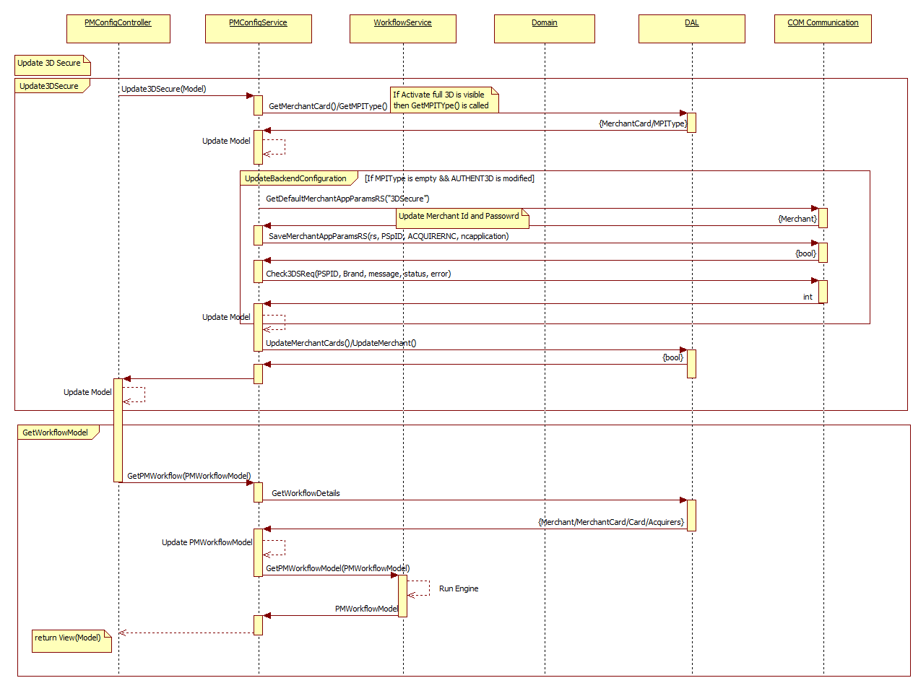

**Figure: Update 3D Secure Sequence Diagram**

### Security

#### Common

|  |  |  |  |  |  |  |
| --- | --- | --- | --- | --- | --- | --- |
|  | **Customer** | **Merchant** | **ISP** | **Acquirer** | **MerchantGroup** | **Ogone** |
| **Profile** | NA | NA | 5 | NA | NA | 5 |
| **User authenticated** | NA | NA | Yes | NA | NA | Yes |
| **CSRF validated** | NA | NA | Yes | NA | NA | Yes |
| **Merchant selected** | NA | NA | Yes | NA | NA | Yes |
| **User Action requested** | NA | NA | View Account | NA | NA | View Account |

#### Save

|  |  |  |  |  |  |  |
| --- | --- | --- | --- | --- | --- | --- |
|  | **Customer** | **Merchant** | **ISP** | **Acquirer** | **MerchantGroup** | **Ogone** |
| **User Action Requested = Change Account** | NA | Yes | Yes | NA | Yes | Yes |

## Payment method specific options

This view contains the two main sections.

1. Discount/Surcharge
2. CVC Mandatory

### Navigation and/or Flow

#### Request Origination

This view can be requested from any of the able of payment method detail module.

#### Destination

**Save:** User can update the payment method specific options and stays on the same view.

### Dependent processes

#### External services

#### Mailing system

#### Action tracing

Trace information will be logged in ACTIONTRACE information on updating merchant configuration.

#### Auditing

#### Logging

### Fields and validation

|  |  |  |  |
| --- | --- | --- | --- |
| **Field name** | **Description** | **Validation rules** | **Error messages** |
| **Discount** | Discount Percentage | Decimal |  |
| Numeric – (Minus (-)sign is allowed for configuring surcharge) | Discount is allowed only numeric value. |
| Optional |  |
|  |  |
| CVCMandatory | CVC Mandatory checkbox list | Optional |  |
| CVCMandatoryMissingReason | Checkbox list | Optional |  |
| CVCMissingReason |  | String, Optional |  |
| Max length: 50 |  |

**CVC Mandatory Change Validation**

If current user is ABSSYS or if below condition is satisfied then CVC mandatory is allowed to change,

ISPCONFIG3 bit position is set to 128

OR

ISPCONFIG3 bit position is set to 2048 and current user is ISP and profile is greater than or equal to 75.

### Action events

#### Load

First gets the PSPID, CONFIG4, ISP from merchant based on the current merchant id.

Get ISP, ISPCONFIG3 from ISP based on the merchant ISP.

Get DISCOUNT, MANDATCVC, and CVCMISSINGREASON from merchant cards table.

If MERCHANTCARDS.MANDATCVC is empty then use the 0 value.

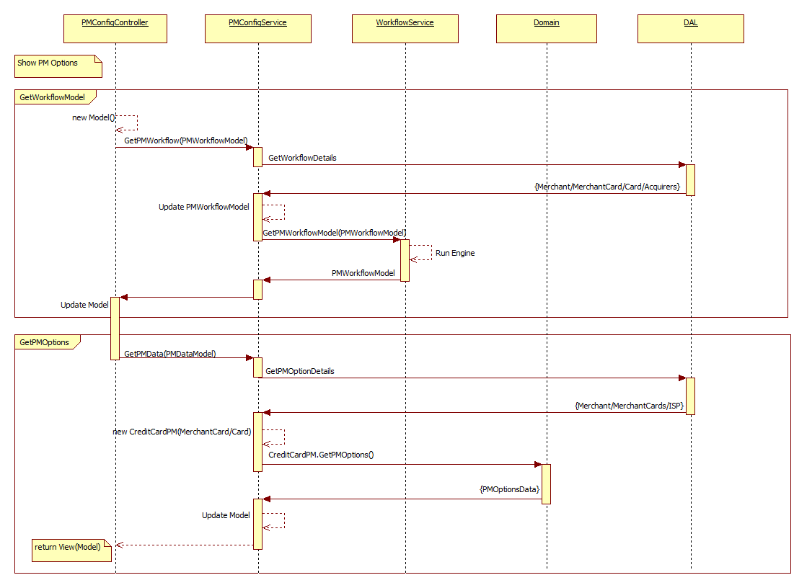

**Figure: Load PM specific options Sequence Diagram**

#### Page rendering

There are mainly two sections as below

1. Discount/Surcharge

This section renders the input box for configuring discount/surcharge. Below caption is displayed for discount

*Configure a discount or a surcharge for this PM (only valid for eCommerce) %.*

Also it displays the help text for how surcharge should be configured as below

*This percentage is deducted from the paid amount. To configure a surcharge, enter a negative percentage*

If the value is not empty then above input field is loaded with value from merchant cards table.

Please see the below image for what information can be contained.



1. CVC Mandatory

This section shows the CVC mandatory information for selected brand available for different products.

Below information message displayed,

*To increase the security of your payments, reduce the fraud risk and to meet requests from certain payment schemes, the CVC for AIRPLUS is predefined as mandatory for all Ogone payment channels. The CVC will not be mandatory for recurring Payments (ECI is 2 or 9), even if defined as mandatory for the brand.*

Table is rendered for CVC detail and it contains three columns as below

1. CVC Mandatory

This column contains the four products with check box

* Direct Link
* eCommerce
* eTerminal
* Batch

Above information is editable and can be selected by checking checkbox if current user is ABSSYS or CVC mandatory change is allowed (Refer CVC Mandatory Change validation section) otherwise it is displayed as read only labels.

1. Display reason CVC missing

This column contains the reason for keep CVC not mandatory. Reason can be mentioned for two products

* eCommerce
* eTerminal

1. Merchant reason for exemption

This information is used to edit/display the reason for exemption. This column is only visible if current user is ABSSYS and CVC mandatory change is allowed (Refer CVC Mandatory Change Validation section).

There will be help information on CVC status as below

*The default status of the CVC will only be changed on special request by the Merchant. To learn more about the reasons to have the CVC mandatory and how to request an exemption from this default rule respectively have the CVC enquiry as mandatory again, click here.*

Bit position for the various options is as below (MERCHANTCARDS.MANDATCVC)

* eCommerce: 1
* eTerminal: 2
* DirectLink: 4
* Batch: 8
* eCommerceMissingReason: 16
* eTerminalMissingReason: 32

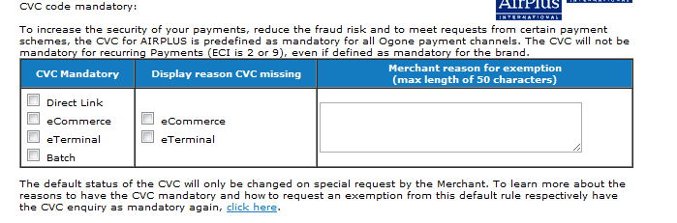

#### Operations

##### Update

**Merchant Cards**

First gets the MANDATCVC, DISCOUNT, CVCMISSINGREASON from merchant cards based on the selected brand and merchant id.

User rights are checked if user is able to activate the payment method or not. For that if ABSSYS user does not have 400 minimum profile and rest all user does not have 5 minimum profile then

If selected Activation field from form is different than stored in database OR merchant status is not subscribed or current user is not ABSSYS then report error and redirect to error page

If user has entered/updated the discount field then it is updated in DISCOUNT field of merchant cards table.

If current user is not ABSSYS then below fields are updated

If values in the CVC mandatory is checked then do the bitwise AND operation between old value of MANDATCVC with 15 like MERCHANTCARDS.MANDATCVC & 15 and add this value to the value available in form field. Update the MANDATCVC field to this value.

If current user is ABSSY and if reason for missing CVC is entered then

Update the CVCMISSINGREASON with this value.

**Merchant**

Now, first gets the COMPLETION, STATUS from merchant table based on the merchant id.

If merchant status is subscribed and completion is not set to 8 i.e. payment method is not configured then updates the completion bit as below

Set COMPLETION = COMPLETION | 8

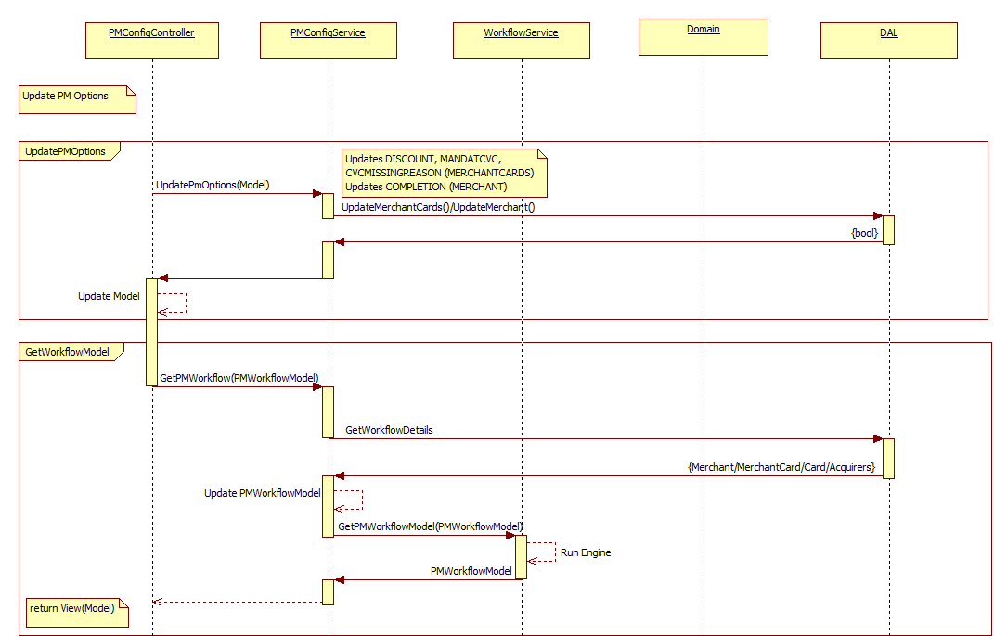

**Figure: Update PM specific options Sequence Diagram**

### Security

#### Common

|  |  |  |  |  |  |  |
| --- | --- | --- | --- | --- | --- | --- |
|  | **Customer** | **Merchant** | **ISP** | **Acquirer** | **MerchantGroup** | **Ogone** |
| **Profile** | NA | Yes | Yes | NA | Yes | Yes |
| **User authenticated** | NA | Yes | Yes | NA | Yes | Yes |
| **CSRF validated** | NA | Yes | Yes | NA | Yes | Yes |
| **Merchant selected** | NA | Yes | Yes | NA | Yes | Yes |
| **User action requested** | NA | View account | View account | NA | View account | View account |

#### Save

|  |  |  |  |  |  |  |
| --- | --- | --- | --- | --- | --- | --- |
|  | **Customer** | **Merchant** | **ISP** | **Acquirer** | **MerchantGroup** | **Ogone** |
| **User action requested** | NA | Change account | Change account | NA | Change account | Change account |

## Acquirer options

This section will contain the information about visuals of the card, how card will look like. Card visual information is only for cofinoga brand. This section is visible only if selected brand is cofinoga and

Current user is ABSSYS or any of the below merchant is selected

SIMULNETRESERVE, RECNETRESERVE, TESTNETRESERVE, DEMONETRESERVE, SIMULOGNETRESERVE, RECOGNETRESERVE, TESTOGNETRESERVE, DEMOOGNETRESERVE

### Navigation and/or Flow

#### Request Origination

Acquirer options can be requested from any of the other tab in the payment method detail module.

#### Destination

User can take below action

**Save:** Updates the card visual information and stays on the same page.

### Dependent processes

#### External services

#### Mailing system

#### Action tracing

Trace information is logged in ACTIONTRACE when any merchant configuration is updated.

#### Auditing

#### Logging

### Fields and validation

|  |  |  |  |
| --- | --- | --- | --- |
| **Field name** | **Description** | **Validation rules** | **Error messages** |
| **BrandVisual** | Dropdown list for brand visuals | String |  |

### Action events

#### Load

This section is only for the cofinoga brand and the list of visuals is fixed as below

ECRANLOUNGE, Cofinoga, Delamaison, 24H00, Tati, BHV.

Base on the above list, different values are fetched such as Site Id, brand visual name, origin etc. All these values are fixed.

Also, gets the BL_BIN field of merchant card table to get the already stored site id, brand visual, origin values.

Binds the list of card visuals based on the list generated as above.

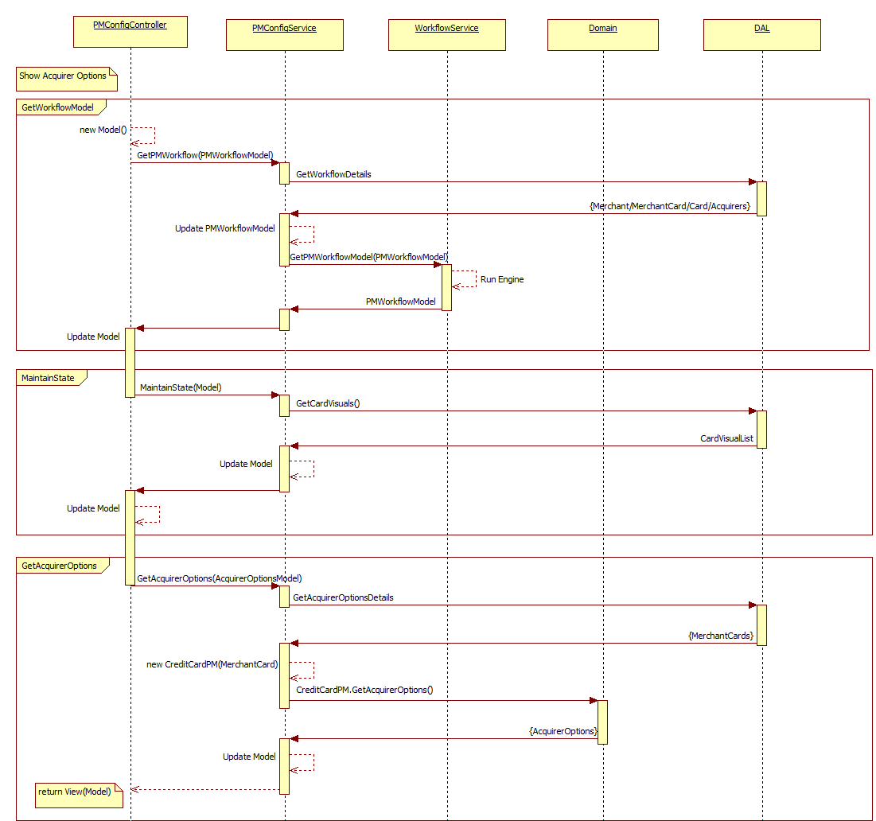

**Figure: Load Acquirer Option Sequence Diagram**

#### Page rendering

Card visual is displayed only if below condition is satisfied

* Current brand is cofinoga
* Current user is ABSSYS or any of the below merchant is selected
  + SIMULNETRESERVE, RECNETRESERVE, TESTNETRESERVE, DEMONETRESERVE, SIMULOGNETRESERVE, RECOGNETRESERVE, TESTOGNETRESERVE, DEMOOGNETRESERVE

If MERCHANTCARDS.BL_BIN is not empty then finds the

* Bin Number: first 30 characters
* Site Id: 31 to 60 characters
* Origin: 61 to 80 characters



#### Operations

##### Update

**Merchant Cards**

First gets the BL_BIN field of merchant cards table based on the brand and merchant’s Id.

This view is uses to update the card visual selected from the list. It only updates the BL_BIN field of the merchant cards table.

First user rights are checked if user is able to activate the payment method or not. For that if ABSSYS user does not have 400 minimum profile and rest all user does not have 5 minimum profile then

If selected Activation field from form is different than stored in database OR merchant status is not subscribed or current user is not ABSSYS then report error and redirect to error page

BL_BIN is calculated based on the selected card visual and it is calculated as below

Gets the Number, Site Id and origin from the selected visual and create string as first 30 characters will be number, then site id and then origin. This generated string will be updated as BL_BIN in merchant card table.

**Merchant**

Now, first gets the COMPLETION, STATUS from merchant table based on the merchant id.

If merchant status is subscribed and completion is not set to 8 i.e. payment method is not configured then updates the completion bit as below

Set COMPLETION = COMPLETION | 8

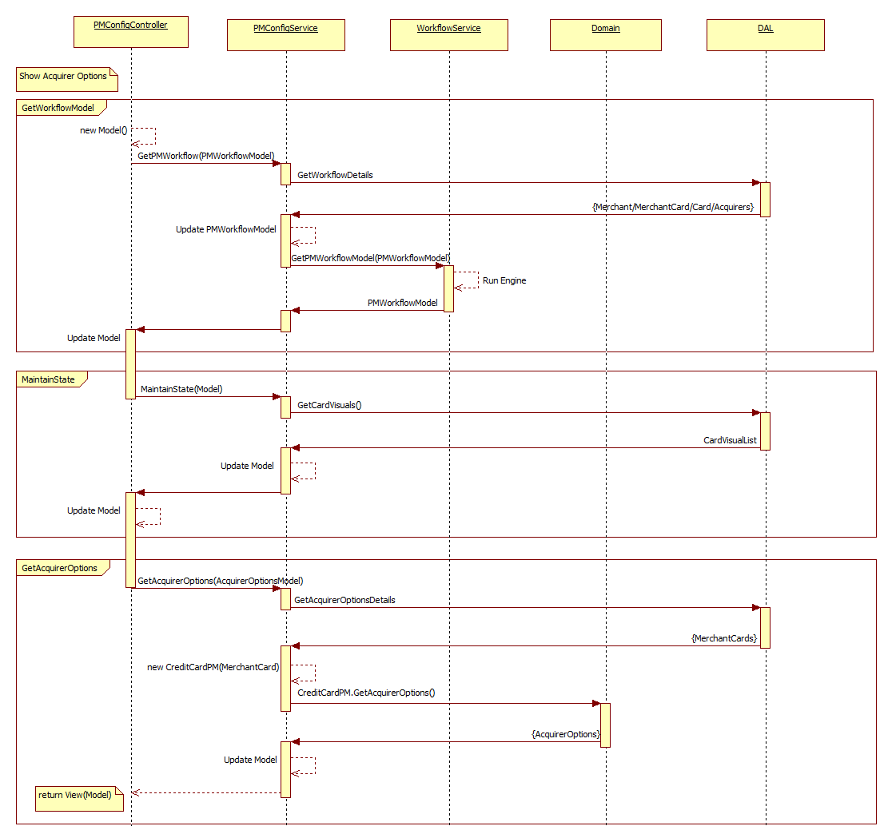

**Figure: Update Acquirer Option Sequence Diagram**

### Security

#### Common

|  |  |  |  |  |  |  |
| --- | --- | --- | --- | --- | --- | --- |
|  | **Customer** | **Merchant** | **ISP** | **Acquirer** | **MerchantGroup** | **Ogone** |
| **Profile** | NA | Yes | Yes | NA | Yes | Yes |
| **User authenticated** | NA | Yes | Yes | NA | Yes | Yes |
| **CSRF validated** | NA | Yes | Yes | NA | Yes | Yes |
| **Merchant selected** | NA | Yes | Yes | NA | Yes | Yes |
| **User action requested** | NA | View account | View account | NA | View account | View account |

#### Save

|  |  |  |  |  |  |  |
| --- | --- | --- | --- | --- | --- | --- |
|  | **Customer** | **Merchant** | **ISP** | **Acquirer** | **MerchantGroup** | **Ogone** |
| **User action requested** | NA | Change account | Change account | NA | Change account | Change account |

## Payment method activation

Payment method activation is the last tab in the payment method detail module. There are three main sections

1. Acquirer confirmation
2. Activation
3. Submit a support ticket

### Navigation and/or Flow

#### Request Origination

Payment method activation is requested from any of the other tab in the payment method detail module.

#### Destination

User can take below action

**Save:** Updates the payment method activation information and stays on the same page.

### Dependent processes

#### External services

#### Mailing system

Sends notification change email if MERCHANTCARDS.ACTIVATION value (payment method status) is changed and this notification is sent to merchant.

#### Action tracing

Trace information is logged in ACTIONTRACE when any merchant configuration is updated.

#### Auditing

#### Logging

Information and error will be logged in text file.

### Fields and validation

|  |  |  |  |
| --- | --- | --- | --- |
| **Field name** | **Description** | **Validation rules** | **Error messages** |
| **Activation** | Activation holds the numeric value – 1/0. | Int |  |
| Required | Activation is required. |
|  |  |
|  |  |
| **AcquirerConfirm** | Read only | Int |  |
| **ActivateCollecting** | Two options - Only used when BCMC is used | Int |  |

### Action events

#### Load

Get the below details from different entities

* ISP, PSPID from merchant
* ISPCONFIG3 from ISP
* ACQCONFIRM, ACTIVATION, AFFILDATE from MERCHANTCARDS

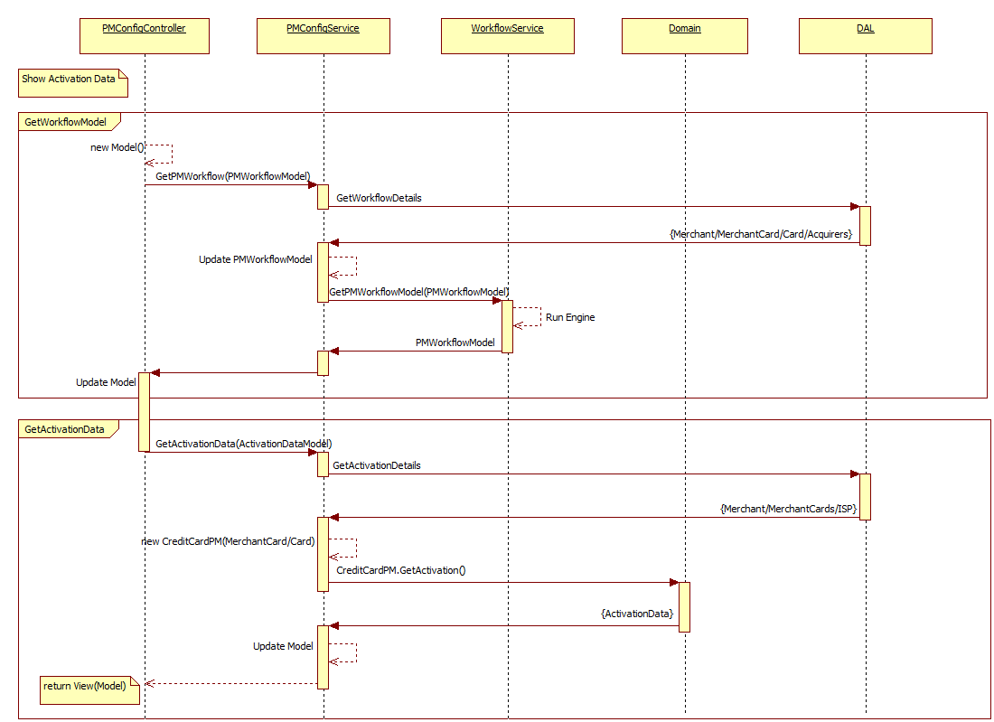

**Figure: Load Activation Sequence Diagram**

#### Page rendering

There are three main sections as below

1. Acquirer confirmation

This section shows whether the contract is confirmed by acquirer. Acquirer information is displayed as read only.

If ACQCONFIRM is 2 then it displays

Acquirer confirmed: Yes

If ACQCONFIRM is 0 then it displays

Acquirer confirmed: No



For BCMC brand:

This section is only visible if current user is ABSSYS.

1. Activation (Yes/No)

This section shows the payment method is activated or yet to activate. Activation is displayed as radio option.

If ACQCONFIRM value is greater than 0 OR merchant account is TEST then Activation is enabled otherwise it is disabled.



For BCMC brand:

It contains two form fields as below

* Activation: Yes/No option.
* Activate Collecting: Yes/No option to activate the collecting contract

1. Submit support ticket

This section is used to submit the ticket to cavaer admin team. This section is only visible based on below condition

MERCHANTCARDS.AFFILDATE is not empty and

Current user is not ABSSYS or (ISPCONFIG3 value should not be set to 256 and current ISP/ABSSYS user must have minimum 75 profiles)



#### Operations

##### Update

**Merchant Card**

Gets the merchant cards detail based on the current brand and merchant id.

First user rights are checked if user is able to activate the payment method or not. For that if ABSSYS user does not have 400 minimum profile and rest all user does not have 5 minimum profile then

If selected Activation field from form is different than stored in database OR merchant status is not subscribed or current user is not ABSSYS then report error and redirect to error page

If Activation is selected “Yes” (1) then

* MCC is mandatory and not configured then below error message displayed

*MCC code is mandatory before payment method activation is possible*

* If MERCHANTCARDS.ACQCONFIRM is 0 and current environment is not TEST environment then

Below error message displayed

*The configuration must be confirmed by the acquirer before to activate the payment method*

For BCMC brand:

Updated the FLAGS3 to 131072 if collecting option is activated.

### Updates the merchant cards below detail

* ACTIVATION: Selected form value
* AFFILDATE: if Activation is 1 then assigns today date

**Merchant**

Now g­­­ets the COMPLETION, STATUS and BRANDDETECTFLAGS from merchant table.

If merchant status is subscribed and completion bit is not set to 8 i.e. payment method not configured and current brand is any of SWITCH, BCMC, MAESTRO, QUATREETOILES, BILLY, CLUB MED, DANKORT and LASER then updates the merchant as below

If merchant status is subscribed and completion bit is not set to 8 i.e. payment method not configured then updates the merchant as below

Set COMPLETION = COMPLETION | 8

If ACTIVATION value is 1 (Yes) and current brand is any of SWITCH, BCMC, MAESTRO, QUATREETOILES, BILLY, CLUB MED, DANKORT and LASER then updates the merchant as below

Set BRANDDETECTFLAGS = BRANDDETECTFLAGS | <BitValueBasedOnTheBrand>

If ACTIVATION value is 0 (No) and current brand is any of SWITCH, BCMC, MAESTRO, QUATREETOILES, BILLY, CLUB MED, DANKORT and LASER then updates the merchant as below

Set BRANDDETECTFLAGS = BRANDDETECTFLAGS & ~<BitValueBasedOnTheBrand>

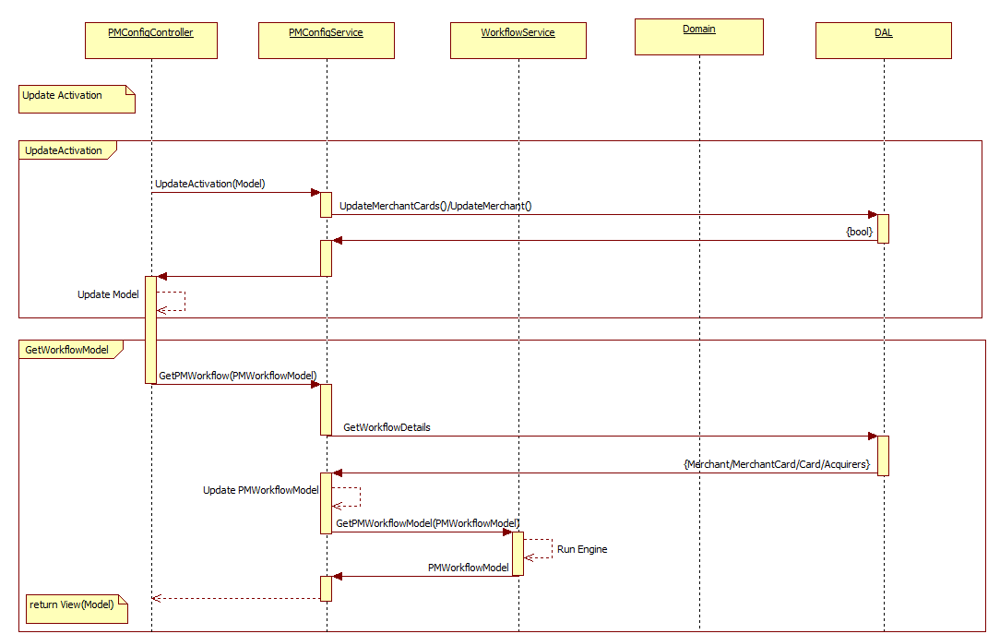

**Figure: Update Activation Sequence Diagram**

##### Submit a support ticket

This event is used to redirect to ticketing module. User can submit their query to support team.

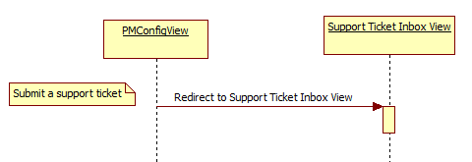

**Figure: Submit a support ticket Sequence Diagram**

### Security

#### Common

|  |  |  |  |  |  |  |
| --- | --- | --- | --- | --- | --- | --- |
|  | **Customer** | **Merchant** | **ISP** | **Acquirer** | **MerchantGroup** | **Ogone** |
| **Profile** | NA | ­­­­­­­­­5 | 5 | NA | 5 | 5 |
| **User authenticated** | NA | Yes | Yes | NA | Yes | Yes |
| **CSRF validated** | NA | Yes | Yes | NA | Yes | Yes |
| **Merchant selected** | NA | Yes | Yes | NA | Yes | Yes |
| **User Action requested = View Account** | NA | Yes | Yes | NA | Yes | Yes |

#### Save

|  |  |  |  |  |  |  |
| --- | --- | --- | --- | --- | --- | --- |
|  | **Customer** | **Merchant** | **ISP** | **Acquirer** | **MerchantGroup** | **Ogone** |
| **User Action Requested = Change Account** | NA | Yes | Yes | NA | Yes | Yes |